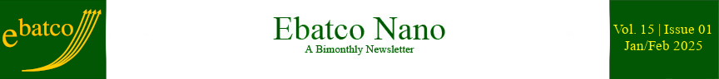

Nano Brief

Ebatco, represented by President, Dr. Dehua Yang, Vice President, Ms. Ming Li, and Materials Scientist, Dr. Lawrence Anderson, exhibited at MD&M West in Anaheim, CA, February 4-6. The Ebatco representatives were grateful to all of the booth visitors. They have enjoyed meeting with you and learning about your products and applications. We hope to have an opportunity to support your unmet material and device testing needs soon.

To keep pace with market needs, and to meet and greet our existing and potential customers continuously in 2025, Ebatco will exhibit in several additional regional and national conferences and exhibitions as listed below:

- March 1-5 – Pittcon Conference and Exposition, Booth #1252, Boston Convention and Exhibition Center, Boston, MA
- March 20 – ASM International MN Chapter Symposium: Materials Joining - Techniques and Considerations, Hennepin Technical College, Brooklyn Park, MN
- April 25 – MMS Annual Spring Symposium: Correlative Microscopy, Minnesota Landscape Arboretum, Chaska, MN
- May 19-22 – Society for the Advancement of Material and Process Engineering (SAMPE), Booth #F9, Indiana Convention Center, Indianapolis, IN, representing Kyowa Interface Science Co. Ltd.
- September 28-October 1 – The Advanced Materials Show (USA), Booth #429, Greater Columbus Convention Center, Columbus, OH
- October 21-22 – MD&M Minneapolis, Booth #2528, Minneapolis Convention Center, Minneapolis, MN
- November 16-20 – ISTFA, Booth #408, Pasadena Convention Center, Pasadena, CA

Please put on your calendar and arrange time to visit our booth if you will attend any of the events. Our staff scientists and executives will be ready to discuss with you on how our ISO 17025 accredited lab services could provide solutions to your R&D, quality assurance and failure analysis challenges. We hope to see you soon!

Ebatco

Ebatco welcomes two new Nano Analytical and Testing Lab Technicians: Mr. Rakesh Plantz and Mr. Duncan Quinn.

Mr. Rakesh Plantz graduated from the University of Minnesota Twin Cities in 2024 with a B.S. degree in Materials Science and Engineering. At the University of Minnesota, Rakesh studied many materials science and engineering related subjects such as characterization and testing of materials, additive manufacturing and environmental consciousness. He also worked on a project designing sustainable packaging solutions. As a Nano Analytical and Testing Lab Technician at Ebatco, Rakesh hopes to use his knowledge and skills to perform nano-scale materials testing and to enhance Ebatco's engagement with target markets.

Mr. Duncan Quinn graduated from the University of Minnesota Duluth with a B.S. degree in Chemical Engineering. During his studies, he modeled sustainable natural gas extraction techniques for anaerobic digestion within wastewater treatment systems. He also interned at Entegris where he investigated mechanical and structural properties of polymeric compounds like nylon, cyclic olefin polymer, and polycarbonate carbon fiber composite materials. After graduating, Duncan acquired his Engineer in Training License. He is excited to combine his engineering approach with Ebatco’s culture of analytical excellence and is looking forward to satisfying Ebatco customers’ needs in chemical and thermal mechanical analysis areas.

Case Study

Hydrophilicity and Hydrophobicity of Stents Determined
using Micro Contact Angle Measurements

Hemocompatibility, lubricity and durability are three of the most important characteristics of coronary, iliac/biliary, peripheral and ureteral stents. To optimize these properties, a variety of materials and coatings have been developed, each with unique surface properties. Hydrophilicity and hydrophobicity affect hemocompatibility, durability, and lubricity making it a vital property to control and measure during the design and application of the stents. Hydrophilicity and hydrophobicity can be tested on larger surfaces by using a contact angle meter, however the complex shape and small width of a stent strut present a great obstacle for traditional contact angle measurements, as the liquid drop may be much larger than the feature to be tested. The Micro Contact Angle Meter equipped at Ebatco provides an ideal solution to that issue and allows for greater insight into the surface properties of the coatings and materials of micro-scale medical device features such as stent struts.

The microcontact angle meter is specially designed for the needs of measuring contact angles at microscale. The picoliter to nanoliter droplets are generated, controlled and delivered by a pneumatic system and a glass capillary with an inner diameter of 5-50 µm. The orthogonally-arranged vertical and horizontal high magnification optics guide the micron-sized drops to be precisely placed on microscopic features. The high-speed camera and powerful software allow for accurate capture and analysis of the Sessile drops for micro contact angle measurements. In addition to its broad applications in many industries, the micro contact angle meter is conveniently suited to the wettability analysis of stents, catheters, guide wires, lead wires and other medical devices that are too small to be tested with the conventional contact angle measurement instruments.

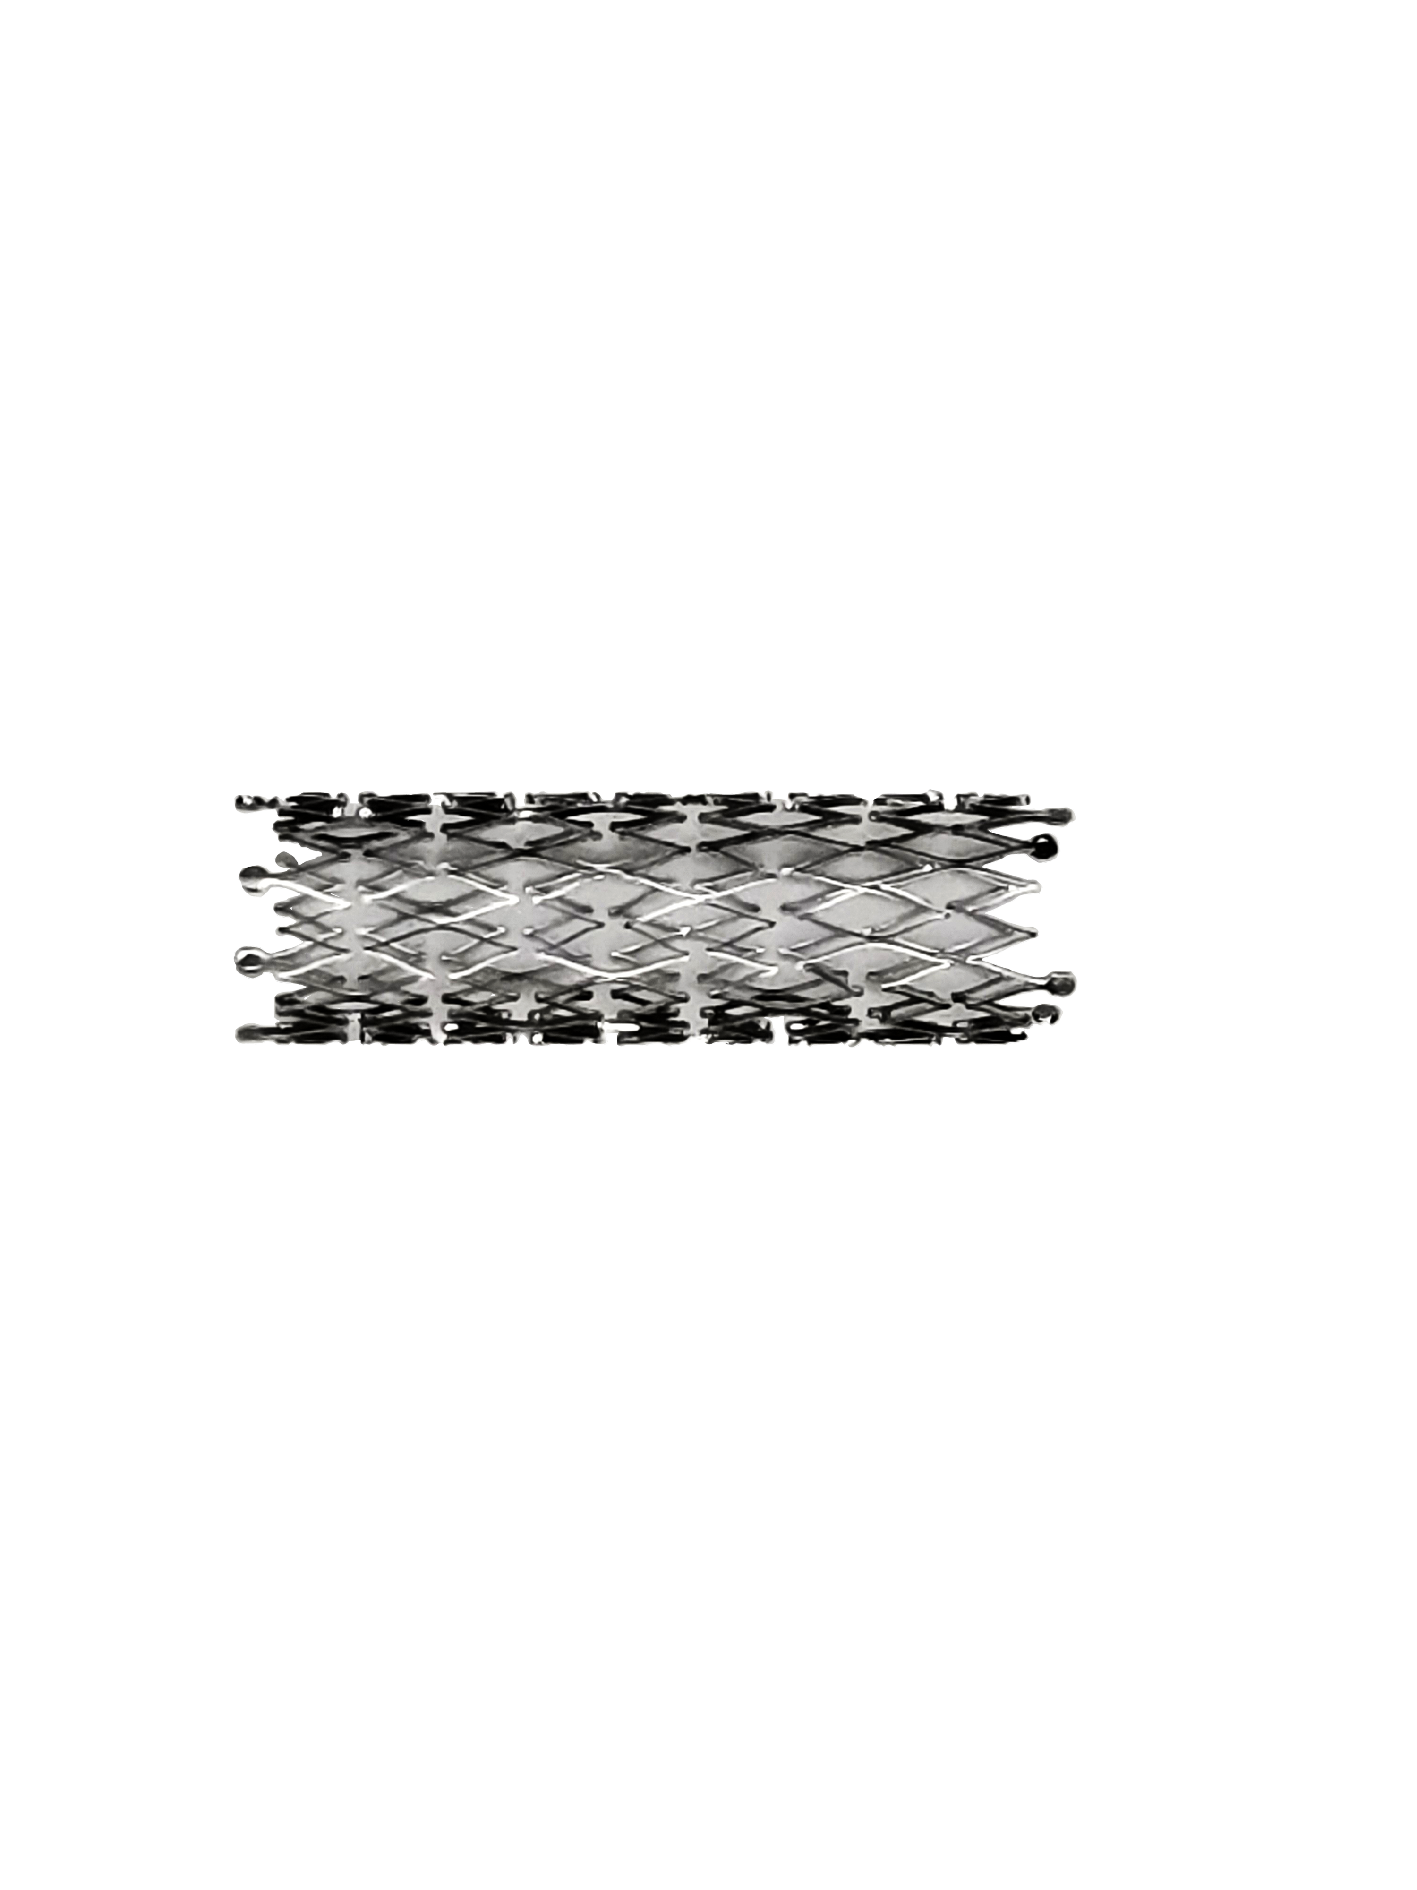
Figure 1. Optical image of an EVERFLEX peripheral stent.

To demonstrate the usefulness of the micro contact angle measurements, 5 kinds of commercially available stents: an iliac/bilary stent, two peripheral stents and two ureteral stents were tested. Figure 1 is an image of the EVERFLEX stent tested. In general, a total of 10 tests per stent were conducted. The Lubri-Flex stent was tested before and after soaking in water, as its usage instructions dictate. Figure 2 shows the average water contact angle of each kind of stent. Figure 3 presents images of water droplets on stent struts from which micro contact angles were measured.

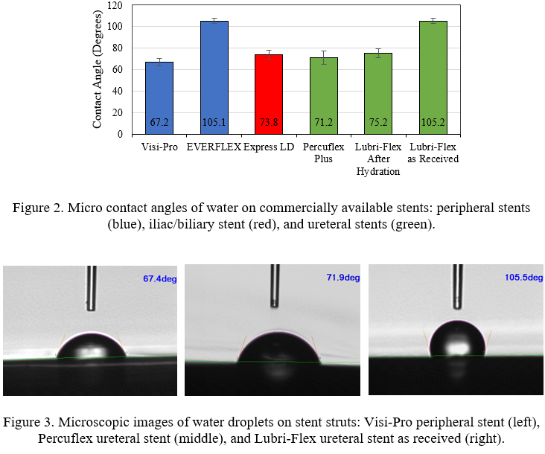

As can be seen from Figure 2 and Figure 3, differences in water contact angles were found among the stents tested. Visi-Pro and Express LD stents are made of uncoated stainless-steel and have less than 90-degree water contact angles, and thus are hydrophilic. Despite being made of similar kinds of materials, the two stainless steel stents’ water contact angles differed by more than 6 degrees possibly due to compositional and/or morphological differences. Everflex stent is made of nitinol and exhibit a more than 90-degree water contact angle, and is regarded as hydrophobic. Based on the contact angle results, Percuflex Plus is hydrophilic. Lubri-Flex stent is hydrophobic as received and becomes hydrophilic after soaking in water.

Research regarding peripheral stents has shown that hydrophilic surfaces decrease thrombosis significantly while hydrophobic surfaces slow degradation of the stent, leading to a longer lifetime. In ureteral stents, hydrophilic surfaces enhance the lubricity of the stent which increases patient comfort during placement and removal. Optimization of the hydrophilicity and hydrophobicity of stent surfaces is vital for the stent performance and for stent user’s safety and comfort. Micro contact angle measurements are proven to be essential, useful and convenient for determining hydrophilicity and hydrophobicity of the stent surfaces.

To subscribe or unsubscribe to this newsletter, contact info@ebatco.com.

Ebatco, 10025 Valley View Road, Suite 150, Eden Prairie, MN 55344, USA
+1 952 746 8086 | info@ebatco.com | www.ebatco.com

