

Nano Brief

We enjoyed meeting and speaking with many of you at various conferences and workshops this year! Ebatco will be attending and exhibiting at conferences and exhibitions this year in October, and we hope to see you there.

• October 2-4 – BioInterface Workshop and Symposium, McNamara Alumni Center, Minneapolis, MN.
• October 16-17 – MD&M Minneapolis, Booth #2838, Minneapolis Convention Center, Minneapolis, MN.

In addition to the exhibitions, Ebatco is also excited to announce that we will be hosting two events this September and October:

- Joint workshop by Ebatco and Anton Paar USA - Viscosity and Beyond: Improve Product Quality with Modern Rheology
This workshop will include presentations on the principles of rheology and their industrial applications, live demonstrations and small group sessions where attendees will experience hands-on sample testing.
Date: Tuesday, September 17, 2024
Cost: Free of Charge
Location: Ebatco Headquarters, 10025 Valley View Road, Suite 150, Eden Prairie, MN 55344, USA
Additional Information and Registration Link
Contact person and registration:
Mary Franck
Tel.: +1 804-550-1051 Ext. 302
Email: mary.franck@anton-paar.com

- Ebatco Academy Training Course No. 5 – Material Identification Through Chemical and Physical Analyses
This three-day extended workshop will educate and prepare attendees on how to positively identify unknown materials, contaminations, and impurities using FTIR, Raman, SEM, EDS, XRD, and XRR techniques.

Dates: Monday-Wednesday, October 21-23, 2024
Cost: $495/day
Location: Ebatco Headquarters, 10025 Valley View Road, Suite 150, Eden Prairie, MN 55344, USA
Registration: Tel.: +1 952-941-2199, Email: info@ebatco.com

Ebatco

As we continue to grow our business, we have hired on a new talent to expand our expertise and testing lab service offerings. Please join us in welcoming the newest addition to the Ebatco team: Dr. Ellen Monzo, Analytical Chemist.

Dr. Ellen Monzo earned her B.S. degree in Chemistry from the University of Minnesota Duluth, followed by a Ph. D. in Chemistry from the University of Minnesota Twin Cities. As an undergraduate research student, Ellen quantified the photo-induced crosslinking of biodegradable polymer films for agricultural applications. She also studied radiochemistry through the Nuclear Chemistry Summer School, and she conducted radiochemistry research during two summer internships at Lawrence Livermore National Laboratory. Her overarching interest in materials subsequently led her to pursue materials chemistry for her Ph. D. research, which focused on synthesis and characterization of metal-organic framework and perovskite nanocrystalline materials for energy applications.

At Ebatco, Ellen is excited to apply her materials chemistry knowledge and analytical characterization skills to support customer needs.

Case Study

Thixotropy of Ketchup

Ketchup is a popular condiment used throughout the world. Ketchup, after agitation, must regain its structure quickly in order to cling to foods such as fries and hot dogs. Ketchup manufacturers often use a rheometer in the product design and improvement phases for product quality control purposes. Using the Anton Paar Modular Compact Rheometer (MCR) 302e at Ebatco, the flow properties of ketchup can be examined through thixotropy.

Shear-thinning, or thixotropy, is an important property of ketchup that affects consumer satisfaction. In simple terms, ketchup is a thixotropic material because it becomes less viscous when it is subjected to shear stress and becomes more viscous when that stressor is removed. Typically, testing the thixotropy of ketchup consists of three phases that mimic the sample-in a bottle at rest, being squeezed from a bottle, and recovering after being dispensed.

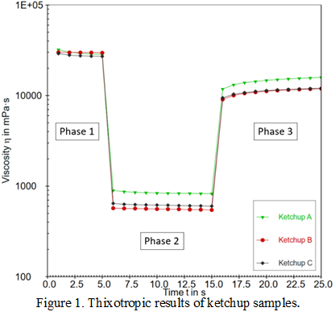

Thixotropy tests were conducted on three ketchup samples (referred to as Ketchup A, B, and C) using a 25 mm parallel plate and 25 mm base plate at a fixed temperature of 24 ºC. Figure 1 depicts the ketchups’ progression during the three phases of testing. Phase 1 represents the ketchup at rest, Phase 2 is the ketchup being subjected to a high shear rate, and Phase 3 is the recovery of ketchup as it returns to a resting state. Table 1 shows the structure recovery characteristics of all three ketchup samples. Among the three ketchup samples tested, Ketchup A had the highest viscosity during Phase 2 and most recovery during Phase 3. Further, Ketchup A has the largest initial recovery of 41.6% and was also the fastest to reach 45% total recovery (in less than 2 seconds).

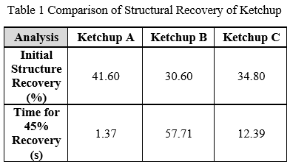

Another important aspect of the flow properties of ketchup is the yield point. The yield point is the lowest shear-stress value above which a material will behave like a fluid. Figure 2 illustrates the shear rate vs. shear stress measurement results obtained on the ketchup samples at 24 ºC. The yield points can be determined using the data shown in Figure 2 as well as the Casson standard equation. The respective yield stress of each sample was as follows: 37.10 Pa for Ketchup A, 29.02 Pa for Ketchup B, and 21.88 Pa for Ketchup C. Ketchup C had a much lower yield stress than the other two samples, suggesting that Ketchup C loses its structure more readily and begins to flow with less force applied.

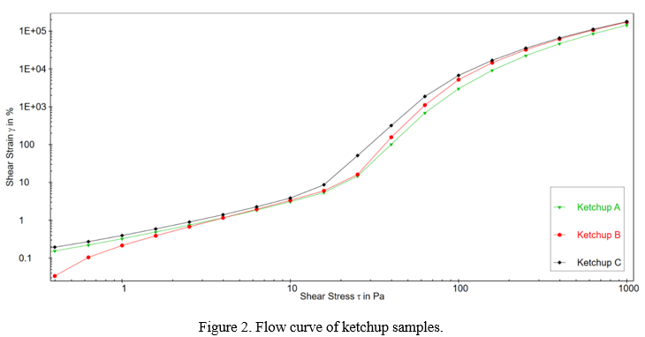

In summary, Ketchup A had the highest yield stress, Phase 2 viscosity, and fastest recovery of all three ketchups samples. Ketchup B had the second highest yield stress, lowest Phase 2 viscosity, and slowest recovery time. Ketchup C had the lowest yield stress, middle Phase 2 viscosity, and middle recovery time. Overall, the results indicate, with some differences, all three ketchup products behave with the same relative thixotropic pattern. Were these samples the ketchups from a manufacturing line, the results would elucidate the degrees of quality variations among batches.

Ketchup may be manufactured differently throughout the world, but all ketchups require thixotropic characteristics. Knowing, measuring, and controlling the thixotropic properties of ketchup is important for maintaining the consistency, quality, and consumer experience. While thixotropic properties may vary from brand to brand, rheology readily serves as a crucial tool in measuring and monitoring those properties for desired product quality and best-possible customer satisfaction.

To subscribe or unsubscribe to this newsletter, contact info@ebatco.com.

Ebatco, 10025 Valley View Road, Suite 150, Eden Prairie, MN 55344, USA
+1 952 746 8086 | info@ebatco.com | www.ebatco.com

