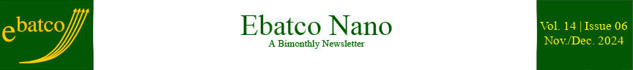

Nano Brief



Dear Customers and Friends,

2024 was a year of remarkable achievements! Before long it will be replaced yet by a thrilling, hope-filled, and peaceful 2025! At this time of year, may our New Year’s greeting letter bring you cheer, respect, care, health, happiness, joy and peace!

This year the Paris Summer Olympics amazed the world with the Olympic Spirit and the extraordinary athletic performances. It was so incredible to see the opening ceremony held outside of a stadium for the first time in modern Olympic history, on and along the beautiful Seine.

In business, the tide of artificial intelligence has been massive in 2024 and has, for certain, gripped the world’s attention for its enormous potential benefits and risks. Nvidia, due to demand for its chips in the applications of AI, has become the market favorite and technology growth leader in this fast-developing field.

Influenced and encouraged by the booming AI and semiconductor industries, Ebatco attended SEMICON West for the first time with an exhibition booth this year. Dr. Lawrence Anderson and I have discussed with over 130 booth visitors and confirmed with passion about how Ebatco’s ISO/IEC 17025:2017 accredited lab services could support them. Prior to the exhibition, a white paper “Nano/Micro Scale Analysis, Characterization and Testing of Semiconductor and Microelectronic Materials” had been released to provide a quick, yet comprehensive guide to worldwide clients who might need assistance in lab services.

In addition, to showcase Ebatco’s contract lab services and its quality product offerings, Ebatco has also participated and exhibited at MD&M Minneapolis, presented at ASM MN Chapter Whole-Day Seminar, represented Kyowa Interface Science Co. Ltd. at American Coating Show, and co-organized a seminar with Anton Paar on Viscosity and Beyond: Improve Product Quality with Modern Rheology.

Another highlight of Ebatco business growth this year is the infusion of several new talents. We welcomed and integrated to our team: Dr. Lawrene Anderson, Materials Scientist; Dr. Jason Scheeler, Analytical Chemist; Mr. Owen Keyes, Mr. Duncan Quinn, and Mr. Rakesh Plantz, NAT Lab Technicians.

As always, the end of a year is a great time to thank our hundreds of new customers who have given us your unwavering trust and the opportunities for us to support you for the first time this year. Please feel free to let us know how we can better serve your analytical and testing needs. We sincerely express our greatest gratitude to our thousands of loyal customers for your continuing business and we hope to generate more successful stories together with you soon.

May each and every one of you have a happy holiday season, and a happy and successful 2025!

Yours truly,

Dehua Yang, Ph. D., FASM
President

To subscribe or unsubscribe to this newsletter, contact info@ebatco.com.

Ebatco, 10025 Valley View Road, Suite 150, Eden Prairie, MN 55344
+1 952 746 8086 | info@ebatco.com | www.ebatco.com

